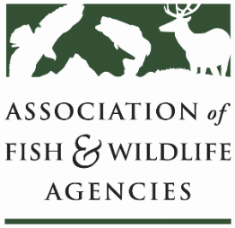

Conservation Reserve Program Working Group
Chair: Todd Bogenschutz (IA)
Vice-Chair: Sal Palazzolo (ID)

Date: Tuesday, September 23rd, 2025
Time: 1:15 – 3:15 pm

115th AFWA Annual Meeting
Tucson, Arizona
Agenda
1:15 pm Review Agenda/Introductions
1:20 pm Primary Nesting Season Dates – Kristen Ellis, USGS Northern Prairie WRC
1:50 pm Federal Partner Update
2:10 pm CRP Outlook
- CRP Improvement & Flexibility Act Language—Andrew Schmidt, Pheasants Forever
- Grassland CRP Marker Bill—Steve Riley, American Bird Conservancy
- State Round Table – Farmbill 2.0
- AFWA CRP Platform change
- CRP – likely 2024 House language, AFWA must haves for CRP
- Give the change to soil productivity factors this signup should they be in statute?
- Other issues
  - Impact of reconciliation bill loophole on future of CRP land rents
  - SE Trees, need variance to burn for management during primary nesting seasons.
  - Other topics from states
3:00 pm NGO/Partner Updates
3:15 pm Adjourn

