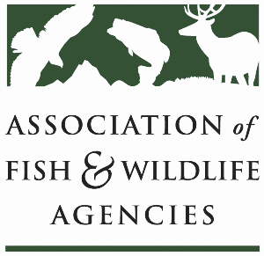

Rcpp Working Group
Chair: Lisa Potter (MO)
Co-Chair: Angela Reseland (WA)

Monday, September 22nd, 2025
1:15 pm – 3:15 pm

115th AFWA Annual Meeting
Tucson, Arizona

1:15 pm Call to Order/Review Agenda

1:20 pm Introductions

1:25 pm Policy Update: RCPP in the Reconciliation Bill

1:40 pm Federal Update: Timing on future grant applications?

2:10 pm Round table: RCPP Grant Recission Impacts/State Roundtable

3:00 pm Partner Updates

3:15 pm Adjourn

