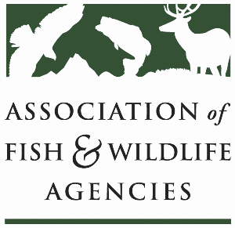

Private LAnds Working Group
Chair: Will Newman, Texas
Vice-Chair: Ray Aberle, Colorado

Monday, September 23rd, 2024
10:00 am – 12:00 pm

114th Association of Fish & Wildlife Agencies Annual Meeting
Madison, Wisconsin

Agenda

10:00 am Call to Order/Introductions/Review Agenda

10:05 am Quick Updates
- Private Lands Delivery “Census” Update/Product
- NABCI Private Lands Guide
- Private Lands Stewardship Academy Recap
- Other updates and discussion for Capacity Development Effort

10:35 am New Business
- Sand County Foundation Presentation
- Private Landowner Recognition Programs
- Regional Associations and Other Private Lands Working Groups
- Previously Identified WG Needs

11:40 am Record Action Items, Form Task Groups, Set Product Goals

12:00 pm Adjourn

