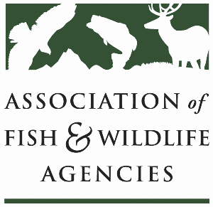

Private LAnds Working Group
Chair: Will Newman (TX)
Vice-Chair: Ray Aberle (CO)

Monday, September 22nd, 2025
10:15 am – 12:15 pm

115th AFWA Annual Meeting
Tucson, Arizona

Agenda

10:15 am Call to Order/Review Agenda

10:20 am Introductions

10:25 am New Business
- Development of SEAFWA Private Lands WG: Brad Alexnader (GA)
- Federal Partner Discussion

11:15 am Old Business
- NABCI Private Lands Guide: Will Newman (TX)
- Other updates and discussion for Capacity Development Effort
- Review of our previously identified “next steps” for the working group and private lands conservation efforts

12:10 pm Record Action Items, Form Task Groups, Set Product Goals

12:15 pm Adjourn

