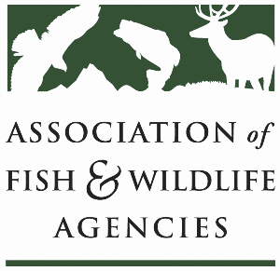

Forestry Working Group
Chair: Brad Alexander, Georgia
Vice-Chair: John Taucher, Pennsylvania

Monday, September 23rd, 2024
3:00 pm – 5:00 pm

114th Association of Fish & Wildlife Agencies Annual Meeting
Madison, Wisconsin

Agenda

3:00 pm Call to Order/Introductions/Review Agenda

3:10 pm FCEP: Implementation and how we can affect draft language

3:40 pm Forestry for wildlife habitat through Farm Bill programs:
- Guest speaker: NRCS National Forester

4:20 pm Roundtable: Updates from states and partners to provide information on:
- Forest Management Incentive for Conservation Reserve Program
- Capacity for Forestry Practices (contractors, habitat crews and other initiatives)
- Forest Legacy Programs
- PM 2.5 mitigation

5:00 pm Adjourn

