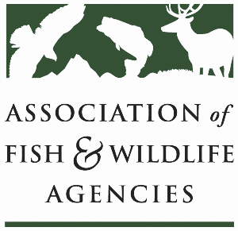

Ocean resources policy committee
Chair: Nate Pamplin (WA)
Vice-Chair: Dave Golden (NJ)

Monday September 22
1:15 pm – 3:15 pm
115th Annual Meeting of the Association of Fish and Wildlife Agencies
Tucson, AZ

Agenda

1:15 pm Call to Order/Review Agenda/Approval of Minutes (Virtual Meeting 2025 and Annual Meeting 2024) – Nate Pamplin, WA

1:20 pm Introductions - All

1:25 pm Government Affairs Update – Bob Caccese for AFWA
- Appointments
- FY26 Federal Budget
- Sport Fish Restoration and Boating Trust Fund Reauthorization
- MMPA Reform Discussion Draft
- Other Marine Legislation
- Update from Bird & Fish Related Conflict Working Group

1:45 pm Federal Partner Updates – TBD

2:05 pm National Fish Habitat Partnership Update – Ryan Roberts, AFWA
- National Fish Habitat Assessment
- New Draft Fish Habitat Action Plan
- 20th Anniversary

2:25 pm State Roundtable Discussion– All

3:00 pm Wrap up and Adjourn – Nate Pamplin, WA

