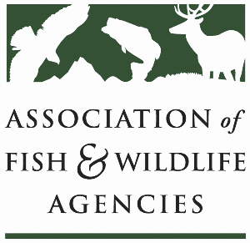

Subcommittee on water
Chair: Julie Carter (AZ)
Vice-Chair: Bob Caccese (PA)

Monday, September 22
10:00 am – 12:00 pm
115th Annual Meeting of the Association of Fish and Wildlife Agencies
Tucson, Arizona

Agenda

10:00 am Call to Order/Review Agenda/Approval of Minutes – Julie Carter, AZ

10:05 am Introductions – All

10:10 am Virtual Pre-Meeting Recap – Julie Carter (AZ)

10:15 am Government Affairs Update – Bob Caccese (for AFWA)
- Federal Budget, Permitting Reform, CWA 401 Listening Sessions

10:30 am SOW Response to Federal Water Policy – All
- Gauging interest and availability in developing positions and making recommendations to FWRPC and AFWA on proposed legislation/administrative actions

10:45 am Instream Flow Council Update – Christopher Estes, AFWA Life Member
- National Center for Ecologically Sustainable Water Conservation and Management

10:55 am Roundtable on State Water Quantity and Quality Issues – All

11:15 am PFAS Discussion – All

11:30 am SOW Work Plan Discussion – Julie Carter, AZ

11:45 am Federal Partner Updates – TBD

11:55 am Wrap Up and Adjourn – Julie Carter (AZ)
- Action items for FWRPC

