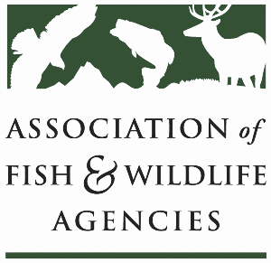

Ocean resources policy committee
Chair: Nate Pamplin (WA)
Vice-Chair: Dave Golden (NJ)

Wednesday April 1
3:30 pm – 5:30 pm
91st Annual North American Wildlife and Natural Resources Conference
Columbus, OH

Agenda

3:30 pm Call to Order/Review Agenda/Approval of Minutes – Nate Pamplin, WA

3:35 pm Introductions - All

3:45 pm Government Affairs Update - Ali Schwaab, AFWA
- FY27 Budget Priorities
- Sport Fish Restoration and Boating Trust Fund Reauthorization
- State Boating Act
- Other Legislation

4:00 pm Federal Partner Updates

4:25 pm National Fish Habitat Partnership Update – Ryan Roberts, AFWA
- Deep dive into 1-2 partnership projects

4:45 pm State Roundtable – All

5:10 pm Discussion on the Future of ORPC – All

5:25 pm Wrap up and Adjourn – Nate Pamplin, WA

