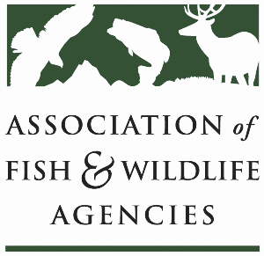

Subcommittee on water
Chair: Julie Carter (AZ)
Vice-Chair: Bob Caccese (PA)

Thursday April 2
10:15 am – 12:15 pm
91st North American Wildlife and Natural Resources Conference
Columbus, Ohio

Agenda

10:15 am Call to Order/Review Agenda/Approval of Minutes – Julie Carter, AZ

10:20 am Introductions – All

10:25 am Virtual Pre-Meeting Recap – Julie Carter (AZ)

10:35 am Government Affairs Update – Ali Schwaab (AFWA)
- Federal Budget, WRDA 2026, WOTUS, CWA 401, USACE Nationwide Permits, Hydropower Bills

10:45 am Roundtable on State Water Quantity and Quality Issues – All

11:10 am PFAS Discussion – All
- Testing for PFAS in State Hatcheries

11:20 am Federal Partner Updates – TBD

11:40 am FWCA Working Group Update – Jen Sheehan

11:55 am Wrap Up and Adjourn – Julie Carter (AZ)
- Action items for FWRPC

