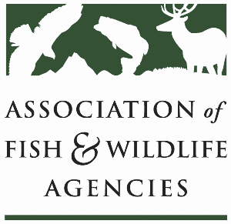

Fisheries and WATER rESOURCES pOLICY COMMITTEE
Chair: Jim Fredericks (ID)
Vice-Chair: Craig Bonds (TX)

Thursday, April 2
1:15 pm – 3:15 pm
91st North American Wildlife and Natural Resources Conference

Agenda

1:15 pm Call to Order/Review Agenda/Approval of Minutes – Jim Fredericks, ID

1:20 pm Introductions - All

1:25 pm Subcommittee and Working Group Reports
- Subcommittee on Water – Julie Carter, AZ
- Drug Approval Working Group – Alan Johnson, IA
- Fish & Wildlife Coordination Act Working Group – Jen Sheehan, AR
- Bird Fish Related Conflict Working Group – Tim Birdsong, TX

1:50 pm National Center for Ecologically Sustainable Water Conservation & Management – Lane Kisonak

2:00 pm Federal Partner Updates – TBD

2:20 pm Public Aquaculture Data Synthesis – Discussion

2:30 pm American Fisheries Society Update – Jeff Kopaska, AFS

2:40 pm National Fish Habitat Partnership Update – Ryan Roberts, AFWA and Julie Carter, AZ

2:55 pm Government Affairs Update – Ali Schwaab, AFWA
- Administrative Updates
  - Rotenone
- Legislative Updates
  - Sportfish Restoration and Boating Trust Fund Reauthorization
  - State Boating Act
  - Cormorants
  - WRDA 2026
  - Others
- FY27 Budget- Fish and Water Priorities - Discussion

3:05 pm Discussion on future of Ocean Resources Policy Committee – Nate Pamplin, WA and Jim Fredericks, ID

3:15 pm Wrap-up Discussion and Adjourn – Jim Fredericks (ID)/All

