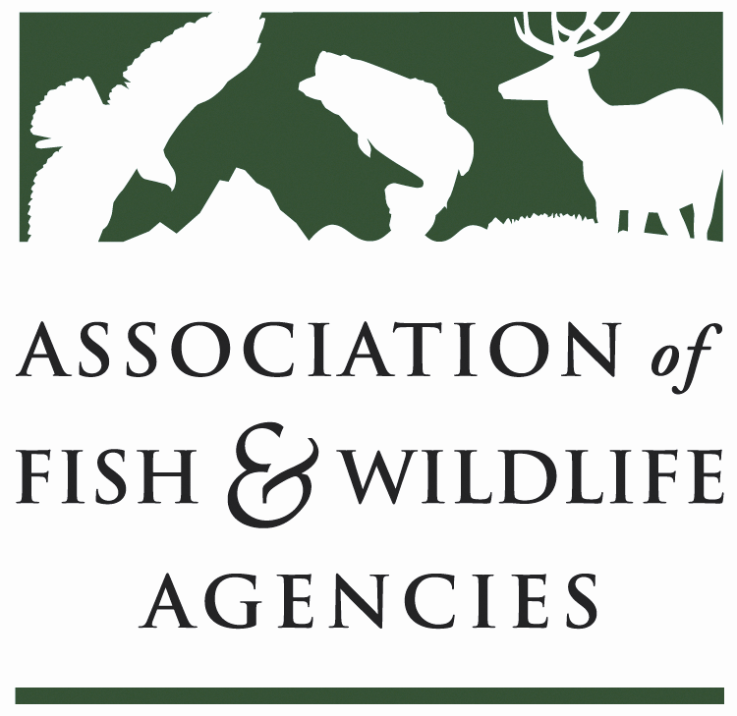

BIRD CONSERVATION Committee I
Chair: Judy Camuso (Maine)
Vice-Chair: Kelly Straka (Minnesota)

Date: 30 March 2026
Time: 1:15 pm – 3:15 pm

91st North American Wildlife and Natural Resources Conference
Hilton Columbus Downtown
Columbus, Ohio

Agenda

1:15 pm Call to Order/Review Agenda

1:17 Introductions

1:20 Partners in Flight
TBD

1:35 New Tools from the Avian Knowledge Network
John Alexander, Klamath Bird Observatory

1:50 Second-generation Anticoagulant Rodenticide Toolkit
Bradley Wilkinson, Association of Fish and Wildlife Agencies

2:05 Reforming the Bird- and Fish-Related Conflict Working Group
Ali Schwaab, Association of Fish and Wildlife Agencies

2:20 Preventing Collisions with Cell Towers and Opportunities for States
Steve Holmer, American Bird Conservancy

2:35 Habitat Management Information Needs for Marsh Birds
Bob Holsman, DJ Case and Associates

2:50 Bird Banding Lab and Breeding Bird Survey
Jennifer Malpass, United States Geological Survey

3:05 Briefing: Southern Wings Advisory Committee
Deb Hahn, Association of Fish and Wildlife Agencies

3:15 Adjourn

