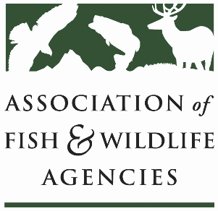

bird conservation Committee ii
Chair: Judy Camuso (Maine)
Vice-Chair: Kelly Straka (Minnesota)

Date: 2 April 2026
Time: 3:30 pm – 5:30 pm

91st North American Wildlife and Natural Resources Conference
Hilton Columbus Downtown
Columbus, Ohio

Agenda

3:30 pm Call to Order/Review Agenda

3:35 Grassland Working Group Report
Alicia Hardin, Nebraska Game and Parks Commission

3:55 Harvest Information Program Working Group Report
Karen Waldrop, Ducks Unlimited

4:15 Resident Game Bird Working Group Report
Mike Reynolds, Ohio Department of Natural Resources

4:35 Waterfowl Working Group Report
Shaun Oldenburger, Texas Parks and Wildlife Department

4:55 Partners in Flight/ Shorebird/ Waterbird Working Group Report
Scott Anderson, North Carolina Wildlife Resources Commission
David Hanni, Wildlife Resources Agency

5:15 Feedback for Bird- and Fish-Related Conflict Working Group
Ali Schwaab, Association of Fish and Wildlife Agencies
Bradley Wilkinson, Association of Fish and Wildlife Agencies

5:30 pm Adjourn

