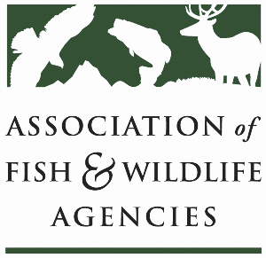

Fisheries and Water Resources Policy
Chair: Jim Fredericks (ID)
Vice-Chair: Craig Bonds (TX)

Wednesday, September 25, 2024
9:00 AM – 11:45 AM

114th Association of Fish & Wildlife Agencies Annual Meeting
Madison, Wisconsin

Agenda

9:00 am Call to Order/Review Agenda/Approval of Minutes – Jim Fredericks, ID

9:05 am Introductions - All

9:10 am Subcommittee and Working Group Reports
- Subcommittee on Water – Julie Carter, AZ
- Drug Approval Working Group – Alan Johnson, IA
- Fish & Wildlife Coordination Act Working Group – Jen Sheehan, AR
- Update on Aquatic Animal Health and Aquaculture Working Group Establishment – Jim Fredericks, ID

9:30 am Government Affairs Update – Ali Schwaab, AFWA

9:45 am Consider Resolution to Support the Instream Flow and Water Level Conservation Training Center Concept – Jim Fredericks, ID

9: 50 am National Fish Habitat Partnership Update – Ryan Roberts, AFWA

10:10 am Break

10:25 am Recommendations to AFS Regarding Names of Fishes Process – Julie Carter, AZ

10:30 am Rotenone Update and Discussion – All

10:50 am Roundtable on AFWA Fisheries and Water Priorities for Next Administration – All

11:10 am Federal Partner Updates
- USFWS Update – Dave Miko, USFWS
- USGS Update – Dave Hu, USGS
- NOAA Update – Heidi Lovett, NOAA
- BLM Update – Sharmila Premdas Jepsen, BLM

11:40 am Wrap-up Discussion – Jim Fredericks (ID)/All

11:45 pm Adjourn

