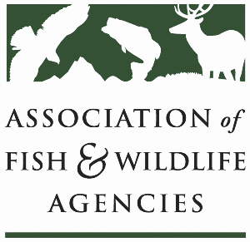

Subcommittee on Water
Chair: Julie Carter (AZ)
Vice-Chair: Bob Caccese (PA)

Monday, September 23, 2024
1:00 PM-2:45 PM

114th Association of Fish & Wildlife Agencies Annual Meeting
Madison, Wisconsin

Agenda

1:00 pm Call to Order/Review Agenda/Approval of Minutes – Julie Carter, AZ

1:05 pm Introductions – All

1:10 pm Virtual Pre-Meeting Recap – Julie Carter (AZ)

1:20 pm Government Affairs Update – Ali Schwaab (AFWA)

1:35 pm Cold Water Releases in the Colorado River – Julie Carter (AZ)

1:50 pm Roundtable on State Water Quantity and Quality Issues – All

2:20 pm Federal Partner Updates

2:40 pm Wrap-up Discussion and Adjourn – Julie Carter (AZ)
- Action items for FWRPC

