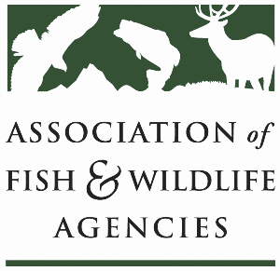

OCEAN resources policy committee
Chair: Nate Pamplin (WA)
Vice-Chair: Dave Golden (NJ)

Tuesday, September 24, 2024
10:00 AM – 11:45 AM

114th Association of Fish & Wildlife Agencies Annual Meeting
Madison, Wisconsin

Agenda

10:00 am Call to Order/Review Agenda/Approval of Minutes – Nate Pamplin, WA

10:05 am Introductions - All

10:10 am NOAA Update– Heidi Lovett, NOAA

10:30 am USFWS Update –TBD

10:40 am Roundtable Discussion on Pinniped Predation – All

11:00 am National Fish Habitat Partnership Update – Ryan Roberts, AFWA

11:20 am Government Affairs Update - Ali Schwaab, AFWA

11:40 am Wrap up and Adjourn – Nate Pamplin, WA

