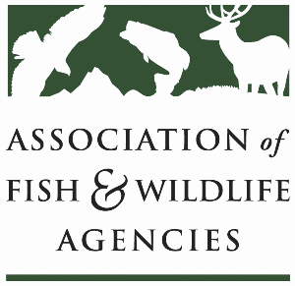

Fisheries and WATER rESOURCES pOLICY COMMITTEE
Chair: Jim Fredericks (ID)
Vice-Chair: Craig Bonds (TX)

Thursday, March 13
1:15pm – 3:15pm
90th North American Wildlife and Natural Resources Conference
Louisville, Kentucky

Agenda

1:15 pm Call to Order/Review Agenda/Approval of Minutes – Jim Fredericks, ID

1:20 pm Introductions - All

1:25 pm Subcommittee and Working Group Reports
- Subcommittee on Water – Julie Carter, AZ
- Drug Approval Working Group – Alan Johnson, IA
- Fish & Wildlife Coordination Act Working Group – Jen Sheehan, AR
- Aquatic Animal Health and Aquaculture Working Group – Ali Schwaab, AFWA
- Bird Fish Related Conflict Working Group – TBD

1:50 pm National Fish Habitat Partnership Update – Ryan Roberts, AFWA

2:05 pm Break

2:15 pm Government Affairs Update – Ali Schwaab, AFWA
- Budget
- Sportfish Restoration and Boating Trust Fund Reauthorization
- Executive Orders
- Other

2:30 pm Roundtable on Fisheries/Water Funding Issues and Priorities – All

2:50 pm American Fisheries Society Update – Jeff Kopaska, AFS

3:00 pm Federal Partner Updates – TBD

3:10 pm Wrap-up Discussion – Jim Fredericks (ID)/All

3:15 pm Adjourn

