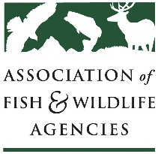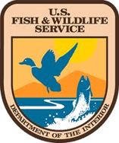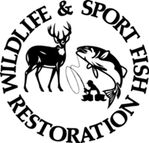

Multistate Conservation Grant Program (MSCGP)
CFDA Number: 15.628

Project Performance Report
☐ Final Report or ☐ Interim Report
Please submit your report to U.S. Fish and Wildlife Service by uploading under your award number in GrantSolutions. Send any questions regarding your report to karen_bennett@fws.gov. The U.S. Fish and Wildlife Service and the Association of Fish and Wildlife Agencies may use resources produced under this grant for reporting and/or publicity purposes.
Project Title:
Federal Award Number:
e.g., F23AP00981
Period of Performance:
i.e., Grant Start & End Date
Reporting Period:
i.e., Reporting Start & End Date
Report Due Date:
Organization Name:
i.e., of grant recipient
Report Prepared by:
i.e., Name and job title
Organization Affiliation:
i.e., of person preparing report
Address:
Phone:
email:
REPORTING GUIDANCE – Please read carefully and create your report based on the following:
Executive Summary of Accomplishments:
Provide a brief description of the grant project’s accomplishments and impacts.
Objectives:
List each objective by title, as it appears in your grant proposal and include the following information for each objective, as required by 2 CFR 200.329:
- Summary of the objective’s “Planned Accomplishments” as described in the grant proposal.
- Describe your “Actual Accomplishments” during the reporting period. Include all pertinent information that documents effort and actual accomplishments, in quantitative and qualitative terms. Be sure all proposed activities under Planned Accomplishments are addressed under the Actual Accomplishments, including an explanation for planned activities that were not conducted or accomplished.
  - Include quantitative statistics from your study or research and / or output metrics (e.g., number of events, number of participants, number of advertisements, number of photos ). Depending on the type of project conducted, you may also present data in tables, charts, and figures.
  - Include qualitative narratives describing what was accomplished and the impact of the objective’s accomplishments as related to the Need and Purpose described in the grant proposal.
  - If deliverables were produced (e.g., reports, peer-reviewed publications, videos, photo collections, websites, social media posts, other outreach or information resources), describe deliverables in the report, describe where the public can find, review or download copies of deliverables, and upload copies of deliverables in Grant Solutions; if files are too large to upload, contact Karen_Bennett@fws.gov to arrange alternate approaches to sharing deliverable files. Be sure all deliverables include the grant acknowledgement statement provided in your grant’s Notice of Award Attachment A and be sure to include the correct federal award number.
- Describe reasons why proposed grant objectives were not met, if applicable. Please share difficulties, problems or challenges encountered in achieving grant objectives, including:
    - Barriers to accomplishment;
    - Actions taken to overcome difficulties; and
    - Lessons learned.
Conclusions (optional): You can include an overall summary of accomplishments at the grant level, overall lessons learned for your grant, and any other narratives including, if possible, a human-interest story that shares an example of how this grant made a difference to those served by the project.
Future Plans and Sustainability (optional): If applicable, include projections and plans about the next phase of the project or the organization’s post-project direction. Sustainability can be demonstrated by including, where applicable:
- Plans for next steps for the project or program.
- Discussion of ways to continue funding the initiative.
- Specific future goals.

