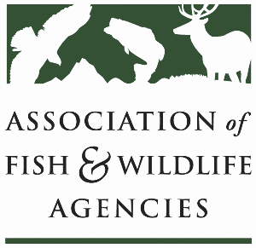

Ocean resources policy committee
Chair: Nate Pamplin (WA)
Vice-Chair: Dave Golden (NJ)

July 2
1:00 – 3:00 PM ET
Microsoft Teams

Agenda

1:00 pm Call to Order/Review Agenda/Approval of Minutes – Nate Pamplin, WA
- Do at Annual Meeting

1:05pm Introductions - All

1:15 pm Government Affairs Update - Ali Schwaab, AFWA
- Federal Budget
- AFWA Funding Priorities for NMFS, Grant Updates, and Check-In with States
- Sport Fish Restoration and Boating Trust Fund Reauthorization
- Other Legislation

1:35 pm Federal Partner Updates

2:00 pm Proposed transfer of NMFS OPR to USFWS – All

2:15 pm National Fish Habitat Partnership Update – Ryan Roberts, AFWA

2:30 pm State Roundtable – All

2:55 pm Wrap up and Adjourn – Nate Pamplin, WA

