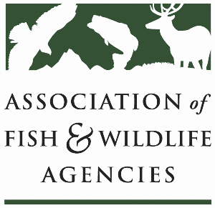

Sustainable Use of Wildlife Committee

91st North American Wildlife and Natural Resources Conference

Hilton Columbus Downtown
Columbus, Ohio

Chair: Eric Lobner (WI DNR)
Vice-Chair: Dave Kay (Alberta)

Wednesday, April 1st, 2026
1:15 PM – 3:15 PM (EDT)

Committee Charge:
Advocate the North American Model of Fish and Wildlife Conservation and promote the sustainable use of fish and wildlife resources at the international level.

Subcommittees and Working Groups:
U.S. Furbearer Conservation Technical Working Group

Agenda
- Agenda review, adjustments, and opening comments (Eric)
- Approval of minutes from the previous meeting (Eric)
- Update from the One Health Committee (Lorisa Smith (MDC), Tricia Fry (MAFWA))
- Environmental Assessment on Beavers in Wisconsin (Keith Wehner, USDA-APHIS-WS)
- Colorado Game Management Team Update (Matt Eckert, CPWD)
- Update on CITES and IT on Canada Lynx in the contiguous US (Deb Hahn, AFWA)
- New Report on Hunter Access across the US (Bob Holsman, DJ Case)
- Final Report on Multistate Grant 2025/Best Management Practices for Trapping Program (Bryant White, AFWA)

