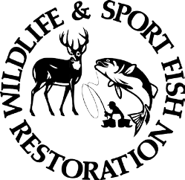
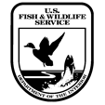
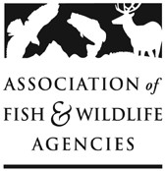
2027 Multistate Conservation Grant Program

**Submission Deadline: July 14, 2026 **

PROPOSAL DETAILS

Descriptive Title:
Recipient Organization:
Recipient Location:
Grant Start Date: | January 1, 2027 | Grant End Date:

The MSCGP Grants Database provides information on past awarded MSCGP from 2001 to the present. Please review this database to avoid duplicating efforts, identify opportunities to build upon past efforts, and leverage previous research, surveys, toolkits, and other deliverables.

Project Abstract Summary/Public Description (4000 characters limit including spaces):

Grant Recipient Contact(s):
  - Primary Principal Investigator of the applicant Organization

  - Primary Authorizing Official of the applicant Organization

ELIGIBILITY INFORMATION
- Organization Type. Select one of the following:

☐State or group of States
☐Nonprofits with or without 501(c)(3) status with the IRS
☐Private, Public and State Controlled Institutions of Higher Education
☐Other

Other eligible applicants include the U. S. Fish and Wildlife Service, or a State or group of States, for the purpose of carrying out the National Survey of Fishing, Hunting, and Wildlife Watching. For purposes of the Multistate Conservation Grant Program (MSCGP), ‘States’ include the 50 U.S. States; the District of Columbia (eligible under Sport Fish Restoration only); the Commonwealths of Puerto Rico and the Northern Mariana Islands; and the territories of American Samoa, Guam, and the U.S. Virgin Islands. Canadian provinces and other non‑U.S. jurisdictions are not eligible applicants and are not counted when determining whether a project benefits more than 50 percent of the States in a U.S. Fish and Wildlife Service region or regional association of State fish and wildlife agencies.

- Beneficiary Information.

If the proposal does not benefit all states, please list the states (abbreviations) it does benefit. You must describe how the project will benefit the states or region selected in order to comply with beneficiary eligibility criteria.

☐Project benefits at least 26 states. Using states’ abbreviations, please list all states that will benefit, or
☐Project benefits a majority (over 50%) of the States in a U.S. Fish & Wildlife Service Region that will benefit, or
☐Project benefits a majority (over 50%) of the States belonging to a regional association of State fish and wildlife agencies (click each association link for the state members, WAFWA, MAFWA, NEAFWA, SEAFWA). Please indicate the regional fish and wildlife association that will benefit.

- The Strategic Priority Addressed. Please refer to the 2027 AFWA Strategic Priorities and list the Strategic Priority addressed by your proposal.

- Eligibility Standards. Is your project eligible according to the Eligibility Standards for activities/species eligibility described in the 2027 Full Grant Proposal Guidelines?

FUNDING PROGRAM(s). Identify grant program(s) relevant to your proposal:

☐Traditional Multistate Conservation Grant Program – Wildlife Restoration (T-MSCGP WR)
☐Modern Multistate Conservation Grant Program – Wildlife Restoration (R3-MSCGP WR)
☐Traditional Multistate Conservation Grant Program – Sport Fish Restoration (T-MSCGP SFR)

PROJECT STATEMENT

- Need:

- Purpose:

- Objectives:

- Approach:

- Results or Benefits Expected:

- Deliverables:

- Timeline:

- Monitoring:

- Evaluation:

- Qualifications of Key Personnel:

